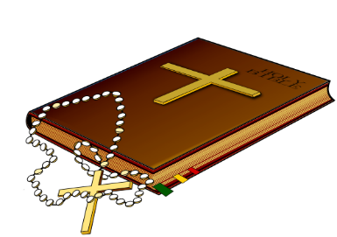
The Glorious Mysteries
Comic Book Retell

Create a comic book retelling the stories of the Glorious Mysteries. Each mystery should be presented in a minimum of four panels, on one page of the comic book, with its title at the top. Each comic must have a minimum of one speech bubble or caption in every panel. Your final product should colorful, with all pencil lines inked over, and all text written neatly or typed and sized to fit your comic’s panels.

TURN THIS PAGE IN WITH YOUR FINAL PROJECT

5 points each:

Colorful cover includes a project title and complete heading information
Each Mystery is presented on its own page which includes the title
Mysteries are presented in order with a minimum of four panels each
The Resurrection of Jesus is told completely and accurately
The Ascension is told completely and accurately
The Descent of the Holy Spirit is told completely and accurately
The Assumption of Mary into Heaven is told completely and accurately
The Crowning of Mary as Queen of Heaven & Earth told completely/accurately
Proper spelling, grammar, punctuation, and capitalization are used
Overall presentation: colorful, appropriate use of space, pencil lines inked over, text written neatly or typed and sized appropriately for panels

points earned %
50 points possible
The Glorious Mysteries
The Resurrection of Jesus

Matthew 28:1-20
Mark 16:1-18
Luke 24:1-53
John 20:1-31

The Ascension

Acts 1:6-12
Luke 24:50-53
Mark 16:19-20
John 16:28-30

The Descent of the Holy Spirit

Acts 2:1-13

The Assumption of Mary

Luke 1:46-50
Revelation 12:1-17

The Crowning of Mary as Queen of Heaven and Earth

Luke 1:32-33
Judith 15:9-10
1Peter 5:4
Revelation 12:1-2

