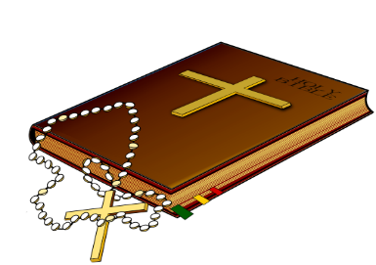
The Luminous Mysteries
Comic Book Retell

Create a comic book retelling the stories of the Luminous Mysteries. Each mystery should be presented in a minimum of four panels, on one page of the comic book, with its title at the top. Each comic must have a minimum of one speech bubble or caption in every panel. Your final product should colorful, with all pencil lines inked over, and all text written neatly or typed and sized to fit your comic’s panels.

TURN THIS PAGE IN WITH YOUR FINAL PROJECT

5 points each:

Colorful cover includes a project title and complete heading information
Each Mystery is presented on its own page which includes the title
Mysteries are presented in order with a minimum of four panels each
The Baptism of the Lord is told completely and accurately
The Wedding in Cana told completely and accurately
The Proclamation of the Kingdom told completely and accurately
The Transfiguration told completely and accurately
The Institution of the Eucharist told completely and accurately
Proper spelling, grammar, punctuation, and capitalization are used
Overall presentation: colorful, appropriate use of space, pencil lines inked over, text written neatly or typed and sized appropriately for panels

points earned %
50 points possible

