Sort the thirteen events discussed in class into two different underlying causes. Write a paragraph for each cause explaining why you sorted the events into these underlying causes. Be sure your analysis clearly explains how each event can be traced back to its underlying cause. Create a timeline of these events, placing those related to the first cause above the line and those related to the second cause below the line. Your project will be scored based on the criteria below:

TURN THIS SHEET IN WITH YOUR FINAL PROJECT
5 points each:
Clear and neat timeline presentation that includes project title, your name, clearly labeled causes, and years spaced at even intervals, with all pencil lines inked over
Events are placed accurately on the timeline with a minimum MM/YYYY format

All 13 events are present on timeline

Timeline summaries are written with proper conventions

Paragraph explanations present well: ink and cursive or typed, margins, layout, legibility

Paragraphs are written with proper conventions

Explanations use proper paragraph format taught in ELA class

Paragraph topic sentences clearly define underlying causes

Concluding sentence of first paragraph transitions into second paragraph

Concluding sentence of second paragraph offers new insight/leaves reader thinking

10 points each:
All 13 events summarized on the timeline in 1-3 sentences

Timeline summaries are concise and detailed

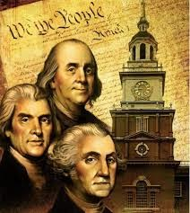
All 13 events are mentioned in explanations

Claims for both underlying causes are factual and persuasive

Connections from each event to its underlying cause clearly explained

points earned %
100 points possible

